**Speciation via Isolation:**

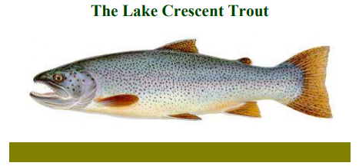

**Set in the north of Olympic National Park in Washington State, Lake Crescent is a large lake covering more than 5,000 acres and exceeding 600 feet in depth. Lake Crescent occupies a valley where a river once drained through current Lake Sutherland and into the Elwha River. Approximately 9,000 years ago a great landslide dammed that outlet, raising the level of the lake. Sea run steelhead and cutthroat trout that once used this river to access the ocean were trapped in the rising lake. A new outlet formed at the Lyre River, however, a waterfall prevents the trout from gaining access to the Strait of Juan de Fuca. The Lake Crescent population of steelhead and cutthroat trout became isolated from other populations of trout on the Olympic Peninsula and have changed genetically (due to mutations and natural selection) over time to become two unique variants, the Beardslee trout (*Oncorhynchus mykiss irideus var. beardsleei* which arose from the steelhead trout) and the Crescenti cutthroat trout (*Oncorhynchus clarki var. crescenti* that arose from coastal cutthroat trout).**

**Distinguishing between the two was not easy even when they were both abundant, up until the early years of the 20th century. Identification today is considerably more difficult. Between 1920 and 1975, stocks of several other varieties of rainbow trout and cutthroat trout were introduced into Lake Crescent. During the 1970s, it was possible to catch trout of almost all shapes, sizes and colors without being certain that any individual was either the native rainbow or cutthroat. People wondered whether the native species of fish remained intact genetically.**

**However, research carried out in the early 1980s by Bryan Pierce of the Colorado State University demonstrated that both species of wild trout have survived in the lake genetically intact. In fact, the Beardslee trout shows a remarkable genetic uniqueness far greater than would be expect through only 9,000 years of isolation. No further stocking of non-native fish is being carried out, and as anglers remove the remaining stock of introduced fish, Lake Crescent might yet revert to the days when it had just its two forms of wild trout.**

**These two very close species coexisted without interbreeding. The two have quite different ecologies in the lake. The cutthroats spawn before the Beardslee trout and in a different place: the Beardslee spawn in the Lyre River, the out-flowing stream of the lake, while most of the Crescenti breed in the inflowing Barnes Creek. Some degree of competition was further avoided by the young cutthroats remaining in their natal streams for the first two years of life, while the Beardslee trout fry enter the lake immediately after leaving the gravel nest. However, both of the Lake Crescent trout feed on the same food sources: small insects in the stream gravel as juveniles, and then on a diet of fish (notably, the kokanee, a form of landlocked sockeye salmon), which results in fast growth rates.**

**A Relict Species:**

**The Olympic Mudminnow**

**(*Novumbra hubbsi*)**

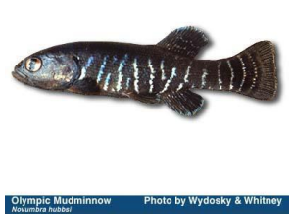

**The Olympic Mudminnow is one of five species worldwide in the family Umbridae and is the only member of the genus *Novumbra*. Three other species are found in eastern North America and one in Europe. Olympic mudminnows are found only in the southern and western lowlands of the Olympic Peninsula and the Chehalis River drainage. They are usually found in slow-moving streams, wetlands and ponds. Within these habitats, mudminnows require a muddy bottom, little or no water flow and abundant aquatic vegetation.**

**Olympic Mudminnows are an example of a relic species. A relic species is a species that once occupied a large area. However, when changes in the environment eliminated some populations of the species, or much of their habitat became unavailable, the remaining population(s) became isolated in what little habitat remained. It is hypothesized that mudminnows may have occurred across much of North America. However, when the glaciers covered the continent during the last ice age, most of the habitat was destroyed. The Mudminnows were only able to find suitable habitat right along the ocean where rivers remained ice free. This explains why the Olympic Mudminnow’s closest relative lives as far away as on the East Coast.**

**Little is known about what can cause mortality (death) in Mudminnow populations. However, they are less abundant when associated with both native and exotic species of fish. It is not known whether this is a result of competition or predation, but some combination is likely. Mudminnows eat various invertebrates.**

**The loss of wetlands in Washington since settlement is estimated to range from 20 to 50 percent. In one part of the Mudminnow's range, an estimated 55 percent of wetlands have been destroyed. Nearly 90 percent of the Mudminnow populations monitored in this study seem to be stable. However, Mudminnows are completely dependent on healthy wetland habitat for their survival. Because of this, and because of the Olympic Mudminnow's very restricted home-range in addition to the continuing loss of wetlands, they are vulnerable and will likely become threatened or endangered.**

**Speciation via Isolation:**

**The Olympic Marmot**

**(*Marmota Olympus*)**

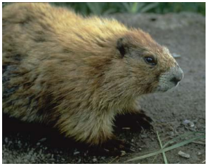

**The Olympic Marmot is a species of marmot unique to the Olympic Mountains. Two species of marmot live throughout the mountains of western North America; the hoary marmot (*Marmota caligata*) and the yellow-bellied marmot (*Marmota flaviventris*). Marmots are the largest of the ground squirrels and generally feed on vegetation in alpine meadows. During or prior to the ice ages, hoary marmots arrived on the Olympic peninsula. They likely migrated from other mountainous areas during the ice age, when even lowland areas resembled alpine/tundra habitats. When the climate warmed, and the forests returned to fill the lowlands, the hoary marmots found themselves isolated on the high peaks of the Olympic Mountains with no genetic connection to the nearest hoary marmot populations in the Cascade Mountains, some 100 miles east. Over time, this genetic isolation lead to divergence via the founder effect, genetic drift, mutation, and natural selection, and eventually, the Olympic marmot became a unique species.**

**A similar thing happened to the critically endangered Vancouver Island marmot (*Marmota vancouverensis*). Vancouver Island was connected to the British Columbia mainland when sea levels were lower. As the oceans rose, it became isolated on all sides by water and they too diverged in isolation to become a new species.**

**The Olympic marmot is unique among all of the world’s marmots in having colonies of one male and two females. Each female breeds every other year. Thus, only one female per colony will have a litter each year. Each colony also includes the one-year old young from the previous year. It is speculated that this behavioral adaptation arose due to the limited number of alpine meadows present in the Olympic Mountains and the inability for young to disperse long distances. Thus, in order to prevent over-population, only one female per season will breed.**